Exploratory Data Analysis

-- 1. Basic Queries

-- SELECT: The `SELECT` statement is used to retrieve data from one or more tables.

-- SELECT all columns

SELECT * FROM customers LIMIT 5;

-- SELECT specific columns with ALIAS

SELECT

product_name AS 'Product Name',

purchase_price AS 'Cost Price'

FROM

products

LIMIT 10;

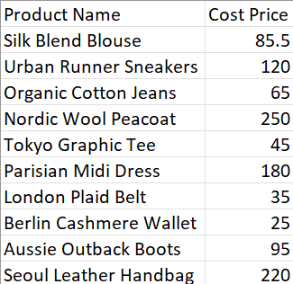

#Average Product price:

-- AVG

SELECT

AVG(purchase_price) AS avg_product_cost

FROM

products;

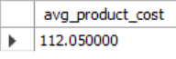

-- Find customers who placed orders after 2023-06-01 AND have spent more than $500 in total:

SELECT

customer_id,

SUM(total_amount) AS total_spent,

COUNT(order_id) AS num_orders

FROM

sales_orders

WHERE

order_date > '2023-06-01'

GROUP BY customer_id

HAVING SUM(total_amount) > 500.00; -- Filters groups AFTER aggregation



-- 4. Built-in Functions for Data Manipulation & Analysis

-- Date/Time Functions (MySQL Equivalents)

-- EXTRACT / DATE_PART -> YEAR(), MONTH(), DAY(), HOUR(), EXTRACT()

SELECT

order_date,

YEAR(order_date) AS order_year,

MONTH(order_date) AS order_month

FROM

sales_orders

LIMIT 5;

SELECT

order_date,

EXTRACT(QUARTER FROM order_date) AS order_quarter

FROM

sales_orders

LIMIT 5;

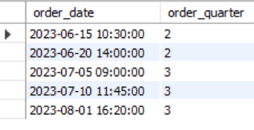  
  
-- Example: Calculate discount percentage, avoid division by zero if selling_price is 0:

SELECT

order_item_id,

selling_price,

discount_amount,

(discount_amount * 100 / NULLIF(selling_price, 0)) AS discount_percentage

FROM

order_items

LIMIT 10;

– -- TO_CHAR -> DATE_FORMAT()

SELECT

order_date,

DATE_FORMAT(order_date, '%Y/%m/%d %H:%i') AS formatted_date

FROM

sales_orders

LIMIT 5;

-- TO_DATE -> STR_TO_DATE()

SELECT STR_TO_DATE("2024-May-24", "%Y-%b-%d") as Date;

–SELECT

order_id,

CONCAT('Order #', CAST(order_id AS CHAR)) AS order_label

FROM

sales_orders

LIMIT 5;

-- POSITION / LOCATE

SELECT

email, LOCATE('@', email) AS at_position

FROM

customers

LIMIT 5;

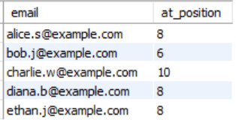

SELECT

order_id,

CONCAT('Order #', CAST(order_id AS CHAR)) AS order_label

FROM

sales_orders

LIMIT 5;

-- SUBSTRING

SELECT

product_name, SUBSTRING(product_name, 1, 10) AS name_start

FROM

products

LIMIT 5;

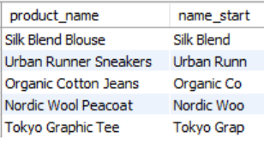

-- Number of customers

SELECT COUNT(*) AS total_customers FROM customers;

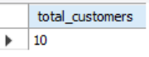

-- Number of orders by status

SELECT status, COUNT(*) FROM sales_orders GROUP BY status;

-- Most popular product categories

SELECT c.category_name, COUNT(*) AS total_orders

FROM order_items oi

JOIN products p ON oi.product_id = p.product_id

JOIN categories c ON p.category_id = c.category_id

GROUP BY c.category_name

ORDER BY total_orders DESC;